**Report 2nd session**

In this session we made several changes to the choice of engine, ultrasonic sensor and SIM800L module. On the one hand for the engine we opted for two brushless motors instead of just one RUNNER SPECIAL 2 engine because of its very high power that will consume a lot of energy and therefore a battery will not suffice. So this choice was more an efficiency choice to reduce weight and save space but also reduce the cost of the car. On the other hand, we chose to use WIFI to communicate with the car instead of using the SIM800L module, because with the SIM800L module you are restricted to sending SMS messages, whereas in WIFI you can do a lot of things with it, such as making a website, communicating with the camera of the car and receiving a video of what is happening in front of it. And finally, the default of the ultrasonic sensor is that it emits waves in all directions which will not be too accurate, so we chose to use the VL53L0X laser for more efficiency and more precision for taking measurements.

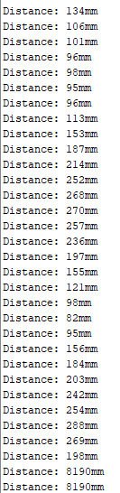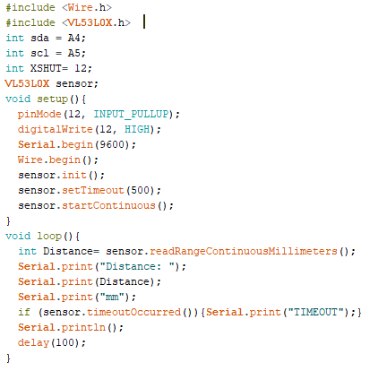

Here are the results obtained with the laser :